ART 3870 PROJECT SUBMISSION TEMPLATE
complete this template, export to pdf and submit on blackboard

NAME: Jasmine Hunt
NET ID: fr7634
COURSE: YEAR (2017)/ QUARTER (FA, WI, SP) /SECTION (01, 02)

Project Title: Assignment 1

Project Description:
This assignment features content from the home, about and portfolio tabs.
Project URL on github.com: https://github.com/jh3870/jhunt3870
Project URL on github.io:
Project URL on ada.csueastbay.edu:

Project Sketches:
(one for each page in the project – scaled to take the whole page width, not distorted/stretched)
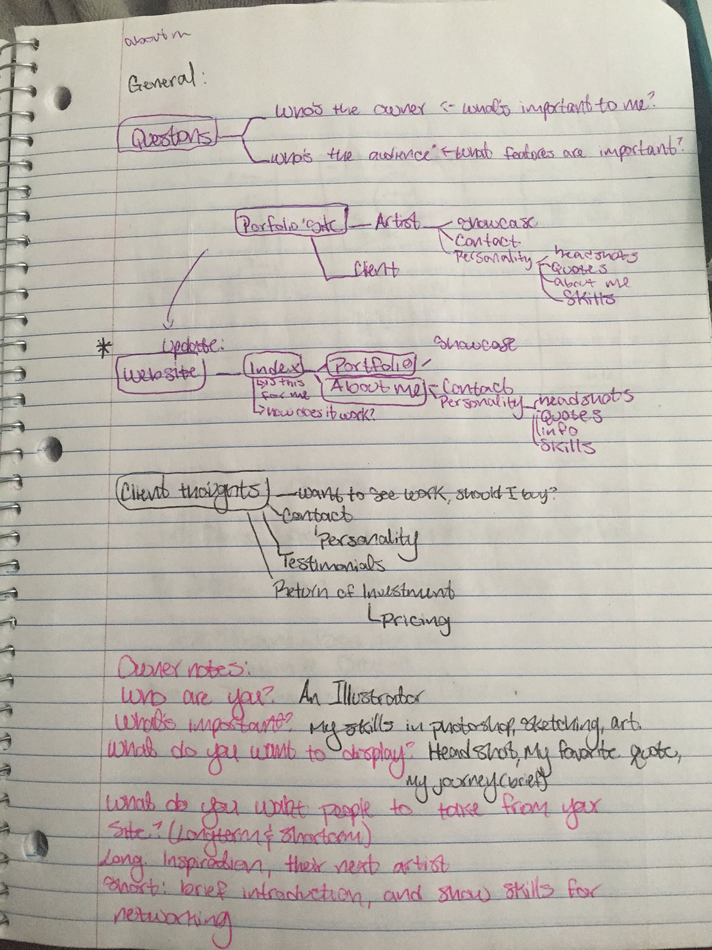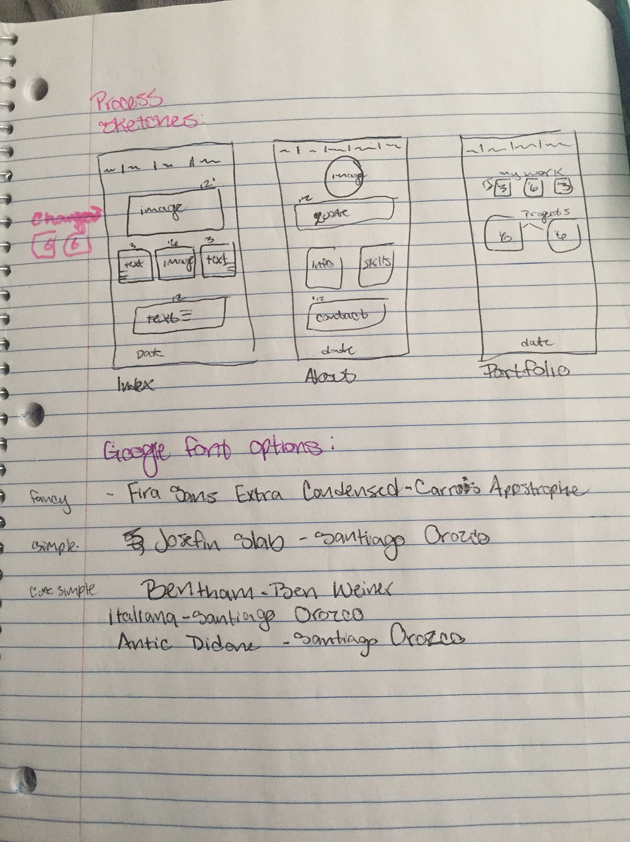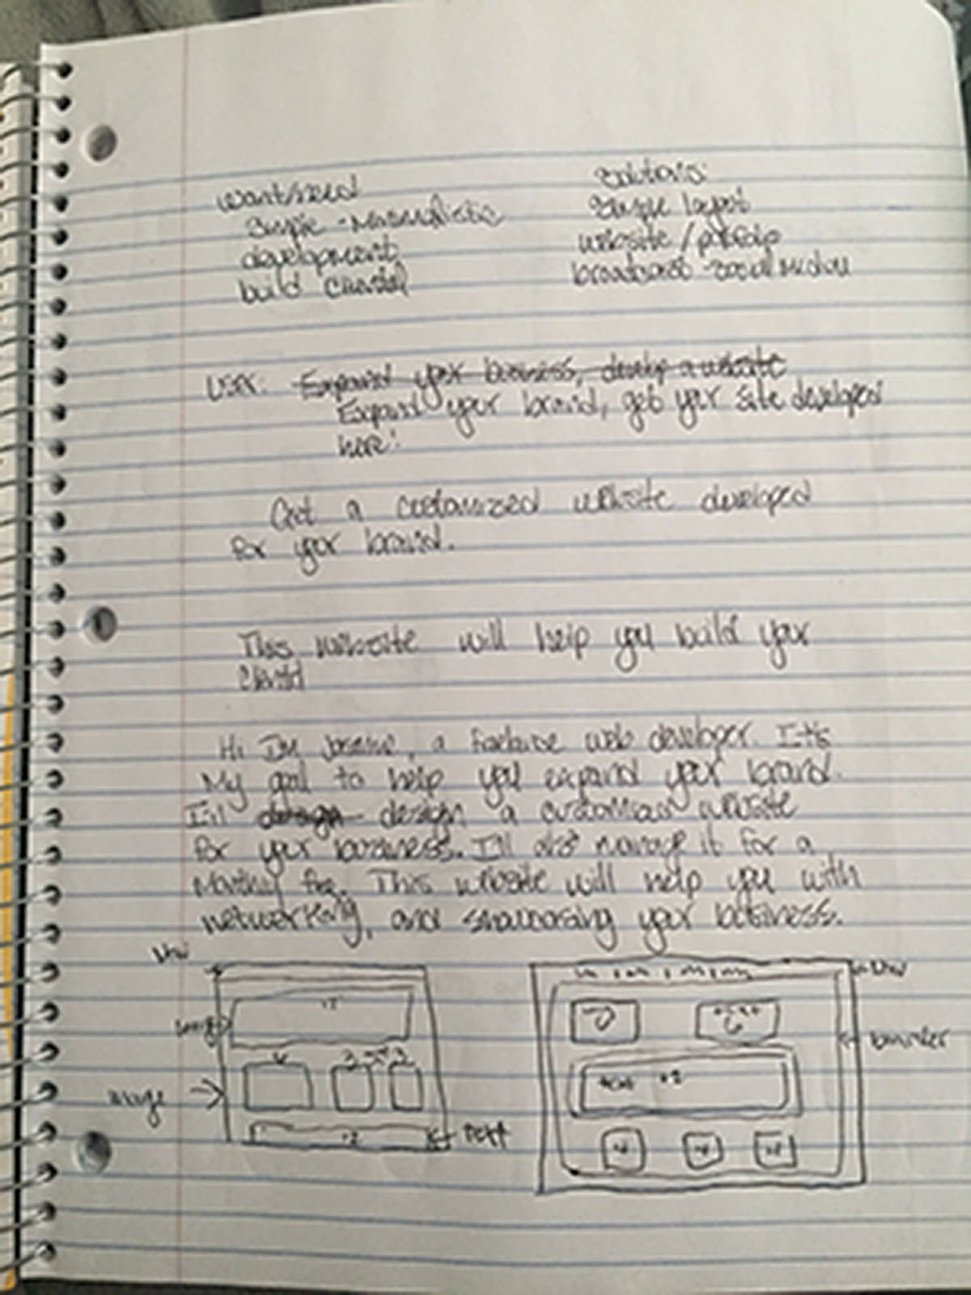

Project Design considerations:
(Explain 3 of your major design decisions)
I wanted a simple design, not too overwhelming to the eye. I chose cooler colors and textures.

Project Screenshots:
(one for each page in the project – scaled to take the whole page width, not distorted/stretched)

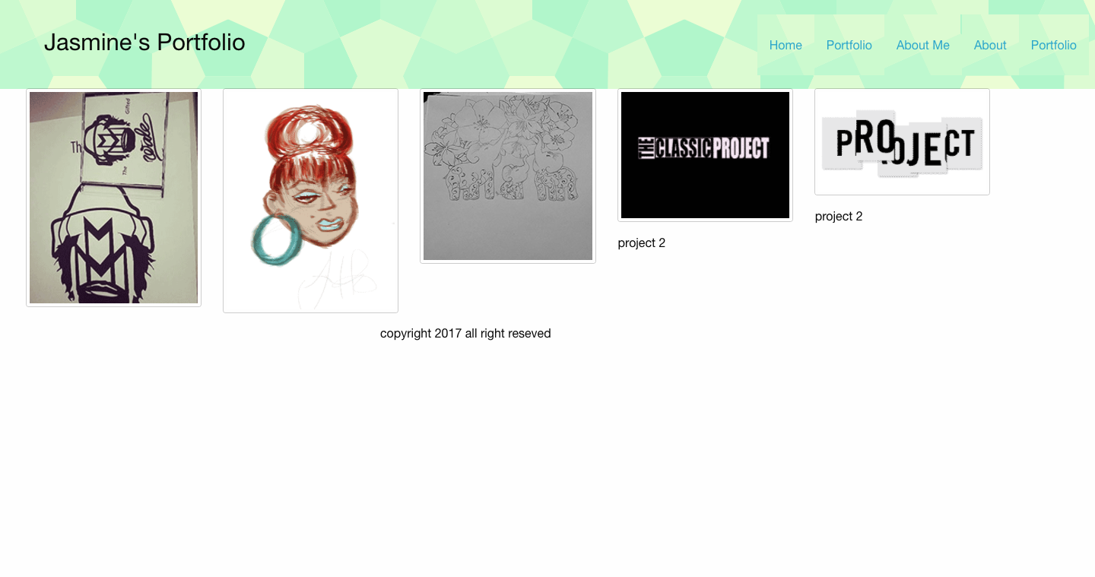

Project Reflection:
(250 words – reflective writing –What was the most challenging part? What was the most exciting part now that the project is done? What did you learn in this assignment, what is your biggest takeaway?)
The most challenging part was getting everything together. Organizing took some time. Then the layout too a lot of time as well. The content was also a bit challenging. I used the books and some tutorials to help me with the process. I learned that while it looks simple, it takes a lot of time to develop a page. I enjoyed learning new styles for my pages. I’m starting to understand Zurb a bit more now. Github is a still new to me as well. My biggest take away unfortunately, was developing a structure for my time management on my project.

